Base Camp
Resume upgrading your self-management skills and combine your advanced encoding methods to create nuanced systems of learning.
Overview and recommendations
Key dimensions | Self-management, deep processing, mindset
Recommended pace | Most learners see best results with 5 hours of theory over 4 weeks.
Recommended practice | Most learners see best results with 8 to 10 weeks of practice, with most of the theory covered within the first 4 weeks.
Progression tips | Base Camp covers a diverse range of learning and enabler skills. Therefore, the amount of practice varies considerably depending on the types of challenges you face. Most learners choose to spend approximately 8 weeks in this stage, but many stay here for multiple months. Progress at a pace that feels comfortable for you as you consolidate your system. The most technical lesson is "Hipshot".
How this stage helps you
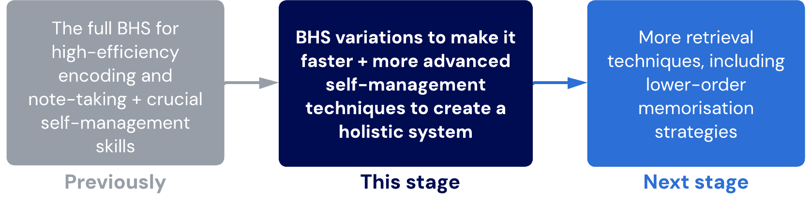

Lessons
- Welcome to Base camp
Gain an overview of Base camp and what this stage prioritises.
- Hipshot: BHS variation
Learn a more efficient method of doing Aim-Shoot cycling, making use of your high competence.
Sub-lessons
- Hipshot implementation
- Hipshot demonstration: Accounting
- Fixed mindset vs. growth mindset
Developing a growth mindset is one of the hardest but most important transformations we can make. This lesson re-emphasises some of the concepts we discussed earlier and extends them.
- Neuroticism

Learn about neuroticism, a core personality trait that affects how we manage stress and uncertainty.
Sub-lessons
- Neuroticism: Prevention
- Neuroticism: Planning
- Neuroticism: Measurement
- Neuroticism: Management
- Neuroticism: Management – chain analysis
- Creating productive habits
Learn our core pillar system for developing new habits consistently.
Sub-lessons
- Anatomy of a habit
- PEER-Peer system: Prep
- PEER-Peer system: Easy, exit, reward and peer
- Time management and prioritisation
Upgrade your prioritisation and time management systems with advanced variants.
Sub-lessons
- Priority myths
- Priority 0+1 system
- OFF-rest timing
Work-rest timing methods (such as the famous Pomodoro technique) can help improve focus. In this lesson, you'll learn about variations of work-rest timing that optimise concentration and energy.
- Final checkpoint – base camp
The end of Base camp signifies a milestone in learning ability.

- Welcome to base camp
Congratulations
Reaching base camp is a fantastic achievement. Well done on getting here!
You have flipped your old learning on its head, so we will take time to adjust and consolidate to ensure your new system is stabilised at unconscious competence.
🔓 Core membership unlocked
You're now eligible to become an iCanStudy core member! Core members are learners in our community who give back by helping others.
Core member benefits
- Priority support via Core member-only Discord channels with iCanStudy coaching staff
- Inside circle - gain early access and beta for new features and have your say in how our program and community develops
- Monthly mentorship and personal development meetings with coaches
- Fortnightly international core member meetings where you can keep each other accountable and connect with the most driven learners in our community
- Exclusive discount on membership renewals
- Access to iCanStudy's direct international network of professionals, employers, and institutions
To learn more about how you can apply, read our article here.
By the end of this stage...
New techniques
Technique | Rationale
Hipshot variation | A time-saving variation of the Bear Hunter System. It will only work if you have mastery over the traditional Bear Hunter System.
Focus training | An ultra-effective method of improving focus over time. One of the highest power techniques in this course.
PEER-Peer system | An extension of the basic BEDS-M system. This comprehensive system can remove procrastination entirely from your life.
Priority 0+1 system | An intermediate time-management and prioritisation technique. Dr. Justin has used this technique for several years.
OFF-Rest timing | A more effective, personalised system of work-rest timing that reduces studying fatigue, improves focus and keeps performance higher for longer every day.
Techniques to continue
Technique | Notes
Bear Hunter System | You should eventually use the hipshot variation.
Scheduling Basics | You should incorporate this with the Priority 0+1 system.
Spaced interleaved retrieval | Your mastery over this should be very high by now.
Techniques to upgrade or replace
Prior Technique | Replaced by…
Aim + Shoot | Hipshot
Maintaining focus | Focus training + OFF-Rest timing
BEDS-M | Focus training + PEER-Peer system
Scheduling basics (prioritising guidelines) | Priority 0+1 system

- Hipshot: BHS variation
Building on mastery
Now that we have close to unconscious competence of the traditional Bear Hunter System with Aim-Shoot cycling, we will build upon it with an advanced variation we call Hipshot.
Hipshot
The Hipshot variation will switch quickly between Aim and Shoot. It is essentially a faster method of Aim-Shoot cycling that exploits the high cognitive load tolerance you have trained and your ability to form relational networks rapidly.
Instructions
- Collect keywords as normal
- Perform the Aim step mentally to identify a hypothetical logic layer.
- Immediately Shoot on your mental model of the logic layer to validate or correct it.
- As you gain clarity about the validity and intuitiveness of the logic layer, commit it to a GRINDE map.
- Repeat this process from step 2 until you work through each of your layers.
- Perform the Skin step once you are satisfied with your initial map and feel ready for refinement.
Correct usage of Hipshot allows you to save time by:
- Drastically reducing the time for Aim
- Reducing the number of iterations before arriving at a map to Skin
While Hipshot increases speed and efficiency, it is vital that quality and accuracy are not impacted. Hipshot is only possible with close to unconscious competence with the traditional Aim-Shoot cycle. If you attempt Hipshot and struggle, please return to the traditional BHS.
Note
Like Aim-Shoot cycling itself, Hipshot often occurs as a natural byproduct of unconscious competence developing with Aim and Shoot individually.

Table of contents
Sublessons:
- Hipshot implementation
- Hipshot demonstration: Accounting

  - Hipshot implementation

Boosting your BHS
With your high level of BHS mastery, we can start applying BHS with more complicated routines and schedules. Expand the accordions below to explore some examples of how BHS (and Hipshot) can be utilised to gain enormous time efficiency advantages.
At this stage of your technique, you should aim to adjust your schedules and routines to learn with some of the more advanced implementation strategies.
BHS implementation variations
Standard BHS implementation
This standard implementation uses all the normal BHS techniques daily. It is a good starter schedule to get used to replacing normal study with BHS.
Characteristic features of the standard BHS implementation:
- Aim always happens during prestudy and covers at least one week's worth of material.
- Shoot happens before (if viable), during, and after main learning events
- Skin always happens after the main learning event.
Time efficiency: 5/10
Difficulty: Low
Instructions:
- Perform Aim step for one week’s worth of material at the end of the previous week (e.g. on Sunday)
- Do a shoot for only the most basic and important concepts/relationships if you have time after the Aim step. If you don’t have time, do this in the morning of, or at any time before learning it in your main learning event.
- Continue the Aim-Shoot cycle during the main learning event, finishing your Shoot step.
- If you have time, do the Skin step at the end of the day or, alternatively, at the end of the week for the entire week’s worth.
You can also do a Skin for each day’s material and continually add to the GRINDEmap with each new day’s content, then re-Skin the entire week again. Both methods will be effective. What’s more important is that you do what you have time for and can do consistently. Some busier weeks may require you to alternate.

Accelerated BHS implementation
This accelerated implementation is an intermediate schedule to get used to working independently from the slower pace and restrictions of classes and lectures.
Characteristic features of the accelerated BHS implementation:
- The Aim always covers an entire topic at a time.
- You are working at a different pace and order than your peers.
- Aim and Shoot always occur before main learning events.
- Skin occurs at the end of the week for an entire topic at once.
Time efficiency: 7/10
Difficulty: Moderate
Instructions:
- Spend one weekend Aiming and Shooting for around 60-70% of the content for the entire next topic you will study for a single subject. This gives you a significant lead and reduces the pressure of trying to "keep up".
- Every weekend, do the same process for a different subject, allowing you to stay weeks ahead of the formal curriculum pace for most subjects at all times.
- During the week, complete the Shoot for the remaining 30-40% of content before, during and after main learning events, much like how you might in the standard BHS. The goal is to finish both Aim and Shoot for the entire topic for a subject within one week of the formal timing.
- Perform Skin at the end of the week.
Attending classes or lectures after you have already self-studied the material is useful as a recheck, re-skin and easy multi-order retrieval session.
Tips:
- Use materials or resources at your disposal for self-study, including Google.
- Don’t worry about covering 100% of the curriculum – you have plenty of chances to pick up things you missed as you will be so far ahead.
- Continue a weekly + monthly interleaved retrieval (appropriate to knowledge type and order) to find gaps, maintain retention, and ensure comprehensive mastery
- Continue lower-order retrieval methods for layer 4 details throughout. This should not take much time if you have effective encoding methods.
- You should still have plenty of time available each week to focus on other subjects as needed for tests, assignments or unexpected difficulties.

Ultra-accelerated BHS implementation
This ultra-accelerated implementation is for students adept at using the standard and accelerated BHS with a high mastery over the core technique. It creates total academic independence from curriculum pacing, creating the most free time and efficiency.
Characteristic features of the ultra-accelerated BHS implementation:
- Aim, Shoot and Skin all happen before main learning events using self-study material
- The time during curriculum weeks is used for interleaved retrieval and getting further ahead or more skills development.
- Entire topics are studied in a single session as the norm.
Time efficiency: 10/10
Difficulty: High
Instructions:
The instructions are brief because it relies on simply cramming through as much as possible, as fast as possible, without sacrificing the quality of learning or retention. The objective is to be so far ahead of formal curriculum pacing that most pressures and challenges are eradicated.
This combination is essentially impossible for most learners who have not had substantial cognitive training.
- On weekends, breaks or other times without classes or lectures, Aim, Shoot and Skin for the entire subject's topic.
- Continue to do this for your subjects every weekend, aiming to be at first a few weeks ahead for one subject, then a few weeks ahead for every subject by the next week, then several weeks ahead for all subjects by the week after.
- Continue with spaced interleaved retrieval and prioritise gap-finding and perfecting your knowledge mastery for the remaining time.
Tips:
- Because your speed of self-study should be much higher than the curriculum pace, you should be able to complete the entire next topic for a subject in approximately one day or even less.
- Don’t worry about getting 100% coverage. Instead, aim for 90% coverage to 90% retention. You have plenty of time to cover the gaps later.
- Attending classes or lectures after you have already self-studied the material is useful as a recheck and easy multi-order retrieval session.

  - Hipshot demonstration: Accounting
View this sped-up version of a 1.5-hour hipshot demonstration performed on VCE Unit 1 and 2 Accounting (Victorian government curriculum in Australia).
This was initially live-streamed on the iCanStudy Students YouTube channel here.

Watch for...
Watch out for differences in Justin's technique compared to yours. How is his approach to this topic different from what you are used to? What about how he chunks and creates relationships? Or how he uses the resources and Google-driven inquiry?

Hipshot demonstration: Accounting
If the pace or level of the techniques in this video is beyond your current level, don’t be discouraged. You will get there with persistence and marginal gains (and in a fraction of the time it took Justin to!)
Final mind map from the session
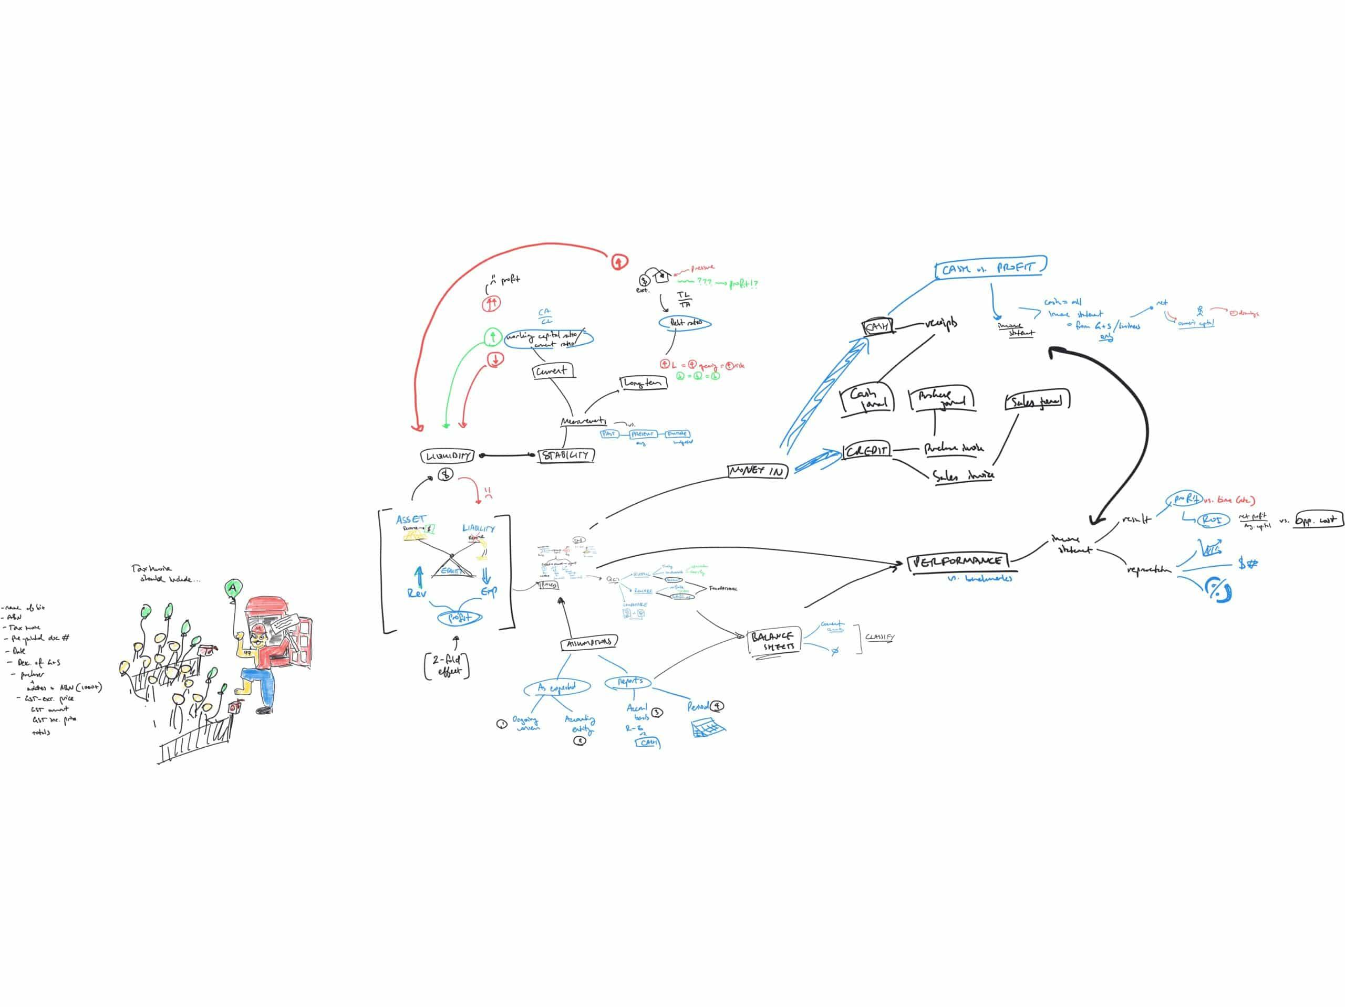

3. Fixed mindset vs growth mindset
Nurturing growth
Those with a fixed mindset see their ability level and intelligence as fixed and unchangeable. To overcome a fixed mindset, we must:
- Take action - one of the easiest ways to change our thoughts, feelings, and beliefs, is through action. it is a misconception that we have to feel like taking action first. We can take action despite not feeling motivated to.
- Reflect effectively - use Kolb's to turn mistakes into learning.
- Focus on the chain performance (see below)
Chain of performance
One useful model to help with your marginal gains is to identify what determines a desirable outcome. Simply wanting an outcome does not create it. By analysing the chain of performance, we can understand which aspects hold us back the most. Our efforts can become more targeted and effective.
What determines outcomes?
- Outcomes and performance (which come from...)
- Skills and processes (which come from...)
- Attributes and behaviours (which come from...)
- Mindsets, beliefs, and identities.

Examples of skills and processes
- Encoding and retrieval skills
- Time management and prioritisation skills
- Self-reflection and problem-solving skills
- Focus and attention management skills
- Emotional self-regulation skills
You can see how deficiencies in any of these skills could cause significant problems with outcomes and performance.

Examples of attributes and behaviours
- Open-mindedness
- Willingness to experiment
- Willingness to face discomfort
- Diligence and commitment
- Patience
- Humility
- Self-compassion
When these attributes (or the behaviours naturally associated with these attributes) are absent, it can cause significant challenges to developing skills. For example, imagine trying to develop the skills in this program without patience or open-mindedness!

Examples of mindsets, beliefs, and identities
- Fear of failure
- Beliefs about intelligence and abilities
- Beliefs about talent and capabilities
- Identity as a learner
- Identity as someone who tries their best
- Identity as someone who always gets back up
Mindsets, beliefs, and identities influence our attributes and behaviours.

Further reading on fixed and growth mindsets
Here is a blog article by Dr. Justin Sung on how fixed mindsets are instilled and create common problems. To dive straight into fixed and growth mindsets, read this great summary article by Maria Popova about Carol Dweck’s famous research on children and praise.
You might also like to read this article by James Clear, the author of Atomic Habits. He discusses how you can use habits to modify your fixed mindsets.

Quiz: Fixed vs growth mindset quiz
Question 1
Which of the following statements are typical of a fixed mindset? Select all correct options.
I'm just not smart enough.
What if I make a mistake?
This challenge is really difficult to overcome.
I need more certainty before I give it a go.
Ans: I'm just not smart enough.
What if I make a mistake?
I need more certainty before I give it a go.
Learning notes
Fixed mindsets often manifest in thoughts about unchangeable attributes, intelligence, and abilities. We fear mistakes because they have implications for our self-worth and capacity. Acknowledgement that a challenge is difficult to overcome is not a sign of a fixed mindset. The response to difficulty is where the difference between growth and fixed mindsets are.

Question 2
Regarding growth vs. fixed mindsets, select the most correct statement below:
Fixed mindsets are characterised by a lack of ambition.
Fixed mindsets are characterised by a lack of effort.
Fixed mindsets are characterised by a lack of experimentation.
Fixed mindsets are characterised by a lack of resilience.
Ans: Fixed mindsets are characterised by a lack of experimentation.

Regarding growth vs. fixed mindsets, select the most correct statement below:
Overcoming fixed mindsets require willingness to experiment, experience with critical reflection, and utilisation of our rational mind to help regulate emotions.
Overcoming fixed mindsets require willingness to experiment, knowledge of critical reflection methods, and actively ignoring the emotional mind.
Overcoming fixed mindsets require fundamentally avoiding the habitual discomfort that arises from mistakes and failure.
Overcoming fixed mindsets require willingness to work hard, persist when tired or exhausted, and remind ourself of our goals to stay motivated.
Ans: Overcoming fixed mindsets require willingness to experiment, experience with critical reflection, and utilisation of our rational mind to help regulate emotions.

Regarding growth vs. fixed mindsets, select the most correct statement below:
Growth mindsets are most easily developed by understanding the nature of fixed vs. growth mindsets deeply.
Growth mindsets are most easily developed by consistently reminding ourselves that experimentation is important.
Growth mindsets are most easily developed by taking action and reflecting on mistakes, without waiting to feel certain or comfortable.
Growth mindsets are most easily developed by failing fast and failing often.
Ans: Growth mindsets are most easily developed by taking action and reflecting on mistakes, without waiting to feel certain or comfortable.

Question 3
Which of the following behaviours can help promote a growth mindset in others?
Celebrating when people identify mistakes after practising.
Asking people about their effort and processes instead of their outcomes.
Giving people advice on how to do techniques correctly and what to look out for before they have first tried it.
Helping someone learn from mistakes constructively.
Ans: Celebrating when people identify mistakes after practising.
Asking people about their effort and processes instead of their outcomes.
Helping someone learn from mistakes constructively.

4. Neuroticism
About neuroticism
Neuroticism is often associated with a fixed mindset and fear of failure. Neuroticism is considered one of the five core personality traits according to the evidence-based Big Five personality framework.
Take an evidence-based personality quiz here.
https://bigfive-test.com/
Neuroticism can be good
Some neuroticism is beneficial as it keeps you safe, creates high standards, and provides motivation. As a result, neuroticism is common among high achievers. However, excessive neuroticism causes significant mental health problems such as anxiety and depression. This may also explain why anxiety and depression are especially prominent in high-performing individuals.
In the sublessons below, we will introduce some frameworks for managing neuroticism through five stages: prevention, planning, execution, measurement, and management.
Table of contents
Sublessons
- Neuroticism: Prevention
- Neuroticism: Planning
- Neuroticism: Measurement
- Neuroticism: Management
- Neuroticism: Management – chain analysis

- Neuroticism: prevention
Principles of prevention
Trigger avoidance can be an effective way to reduce overwhelming neuroticism. To prevent the triggers of neuroticism, there are three aspects we need to address: awareness, attention and analysis.
Awareness
In our busy lives, we often ignore our thoughts and ‘force through’ them by immersing ourselves in more work, responsibilities, and expectations. If these thoughts are not processed healthily, everyday life becomes stressful, with the outcomes of every action feeling like it could be potentially life-ending. This is a psychological phenomenon known as catastrophising.
Step 1: Identifying distortions
Cognitive distortions are mental biases and skewed thoughts that increase anxiety and make us feel bad about ourselves. They are common in highly neurotic individuals and may have acted as a cautionary mechanism for humans in our ancient past. Awareness involves identifying distortions and how they make us feel. Techniques like Kolb's naturally improves emotional self-awareness and root cause analysis.
Expand the accordions below to learn to assess and identify distorted thinking patterns.

Assessing cognitive distortions
From the list below, identify how many typical neurotic thoughts you resonate with:
- Why am I so stupid? Why am I not understanding this?
- I need to get this right; it’s so overwhelming. How am I going to get it perfect?
- I must get top in class. If I don’t I am a loser and I’ll disappoint myself and my family.
- I can’t do it. This is not working. I need to just go back to what I was doing before. It doesn’t matter if it’s not as effective, I’m sure it’ll work out.
- I know I’ve done a lot of practice questions and past papers but I need to do more. The only way to get confident is to do more questions.
- Sleep is for the weak! I need to keep working until I can’t anymore so I secure success. Short term pain, long term gain.
- There’s no point trying. I’m just going to fail again anyway.
- What if I fail? What if the questions I studied don’t come up? What if I forget during the exam?
- I have to get everything perfect and even if it means not sleeping as much or sacrificing my other priorities, I can’t leave it imperfect.
- I wonder what my friends got in the test?... I hope they did badly too.
- But what if I try doing something new, and it doesn’t work and then I’ve wasted all this time and effort?
Identify your level of neuroticism based on how many thoughts you related to:
None or one | Low level of neuroticism. High growth potential.
Two or three | Some neuroticism. Moderate growth potential.
Four or five | High level of neuroticism. Significant limitations to growth potential.
Six or more | Very high level of neuroticism. Highest priority for immediate action.

Attention, analysis and acceptance
Attention involves diving deeper into those emotions and causes as we feel them. Analysis involves objectively dissecting the emotional process, including cues, behaviours, and patterns. This gives us more control over the emotions and their effects on us, rather than letting them affect us without restraint.
We often think that emotions are outside our control or influence. But by being attentive to the paths and ‘life cycles’ of our emotions, we can think about them differently and even influence how they affect us.
Example
If we pay attention to where our anxiety comes from, we may be able to express gratitude for it since it means our brain is trying to protect us from danger. As a result, our anxiety can impact us less negatively, breaking the habit-forming cycles that make anxiety dangerous.
Step 2: Develop acceptance
Expand the accordion below to examine our neurotic tendencies and develop self-compassionate acceptance. Acceptance is critical as it gives us permission and emotional freedom to train ourselves out of our neurotic habits.

Developing acceptance
On a separate piece of paper, for each neurotic thought you have identified above, complete the following questions to help characterise them and their impact on you.
You may be unable to answer some of these questions immediately. If this is the case, you are advised to be attentive to this over the following few days or weeks and fill it in when you have a better self-understanding.
You may continue working through the rest of the program without completing all questions. However, we recommend that you come back to the task to complete it as you are able.
Questions
- How often do I think this way?
- When do I think this way?
  - What triggers these thoughts? Be as specific as you can.
- Why do I think this way?
  - Be as descriptive as possible. Perhaps there are past experiences or parts of your upbringing.
  - Thinking about this can sometimes bring painful or traumatic memories. Accept your thoughts kindly and non-judgementally if this occurs, and take a break. There is no need to force the process.
  - You may need the help of a therapist or experienced professional to guide you through this process if it is very challenging for you, mentally or emotionally. Difficulty at this stage is widespread, especially among high-achievers with a history of overcoming adversity from a young age.
- How does thinking this way affect my mood, confidence and productivity?
  - Be as descriptive as you can, giving examples.

Avoidance behaviours
While avoiding triggers can be effective, there are many situations where trigger avoidance is impossible. When we develop habits of avoiding discomfort and emotional triggers, we can enter into something called avoidance behaviours, which can make anxiety worse.
With avoidance behaviours, we become consumed with avoiding triggers, leading to a restricted and hypervigilant lifestyle in constant fear of triggers. The right balance is to avoid triggers that lead to emotional overwhelm but learn to manage our exposure to unavoidable triggers for a free and healthy lifestyle.

- Neuroticism: planning
Proper planning
Welcome back to marginal gains!
You should break down your final goal (i.e., your desired outcome) into smaller, performance-based goals. This will help you focus on the process rather than just the results. Remember that outcomes also depend on factors outside your control.
Break down your goals
Use the following strategies to help reduce overwhelm
- Use reverse goal-setting to find smaller, performance goals
- Focus on the relationship between outcome, skills, attributes, and mindsets
- Create plans on how you will address the limitations in skills/processes, attributes, or mindsets
- Expect difficulty - it's much easier to persist through difficulty when we expect and accept it
About reverse goal setting
Reverse goal setting is any instance where the desired outcome is dissected into its determinants and then traced back to our current position. The example in this video is one way we can apply reverse goal setting. A slightly different method incorporating force-field analysis may also be appropriate for especially complex goals.
Learn about an alternative method with force-field analysis on the YouTube video here.

How to perform reverse goal setting
- Identify the desired end outcome
- Define the skills, attributes, and mindsets necessary to achieve this with maximal certainty
- (Optional) Rate the level we need to be at each out of 10
- Rate our current level for each of these out of 10
- Create a plan to improve the skills and attributes necessary within the desired deadline (see additional notes below)
Creating a plan
We can create plans with a top-down vs. bottom-up approach. Expand the accordions below to learn about each approach.

Top-down
Top-down means we start at the end and work backwards. The example given in the video uses a top-down approach. This approach is best for when:
- It is easier to deconstruct our goals from the end result (often the case with complex goals that involve several components with a variety of timings)
- It is difficult to assess our current skill and attribute level, or we have not begun to develop them
We can assess the feasibility of the plan by seeing if our true current state is aligned with the supposed current state we arrive at by tracing back from the desired goal towards the present day. If (by working backwards), we find that we currently need to be in a better state than we are, the plan is not feasible and must be reconsidered.

Bottom-up
Bottom-up means we start at the current state and work forwards. The example in the YouTube video uses a bottom-up approach. This approach is best for when:
- Our current skills and attribute level is clearer
- It is unclear what is needed towards the later stages of achieving the goal
- There is a more direct relationship between skills and attributes and the goal
We assess the feasibility of the plan by seeing if we can reach the goal within the deadline based on the step-wise progression of skill and attribute development. If (based on our anticipated pace of development) we are unable to reach the desired level of skill to reach our goals in the time available, the plan is not feasible and must be reconsidered.
Bottom-up approaches are still reverse goal setting if we identify the required skills and attributes based on analysing our desired goal.

Use both
In many cases, we may want to use both a top-down and bottom-up analysis to assess the viability of our plan and see if we have missed anything.

- Neuroticism: measurement

Measuring the process
When planning the process, you need to include metrics. When will you see development, and how much?
With metrics, you’ll know you are doing things correctly because the numbers will show if you are achieving the right processes, learning the right skills and keeping a productive mindset.
Feedback Analysis Loop
The Feedback Analysis Loop (FAL) compares your expectations with what happened in reality.
- If your expectations match reality, you know there’s no problem with your processes.
- If your expectations don’t match reality, you need to adjust your processes as they are unlikely to help you learn the skills and reach your goals.
The FAL is another framework we can apply to Kolb’s experiential learning cycle. Using FALs gives us concrete, manageable information, making reflecting and finding abstractions easier.
Note
FALs can be modified for any need (e.g., studying, sports, personal development). You can add extra steps or criteria depending on what you want to measure.
The only components that need to stay are:
- expectations,
- reality, and
- a comparison between the two.
If your FAL has these three elements, you can modify it however suits you!

- Neuroticism: management

When push comes to shove
From the lessons so far, we have learned steps to prevent neuroticism from overwhelming us.
These steps may initially feel unfamiliar or artificial, but they give you more freedom and time as they release you from the shackles of inefficiency and lack of control. It just takes a bit of effort to free yourself!
Managing neuroticism is about training our brains to not fixate on some thoughts and emotions. This helps us become more focused, less distracted, and more emotionally stable.
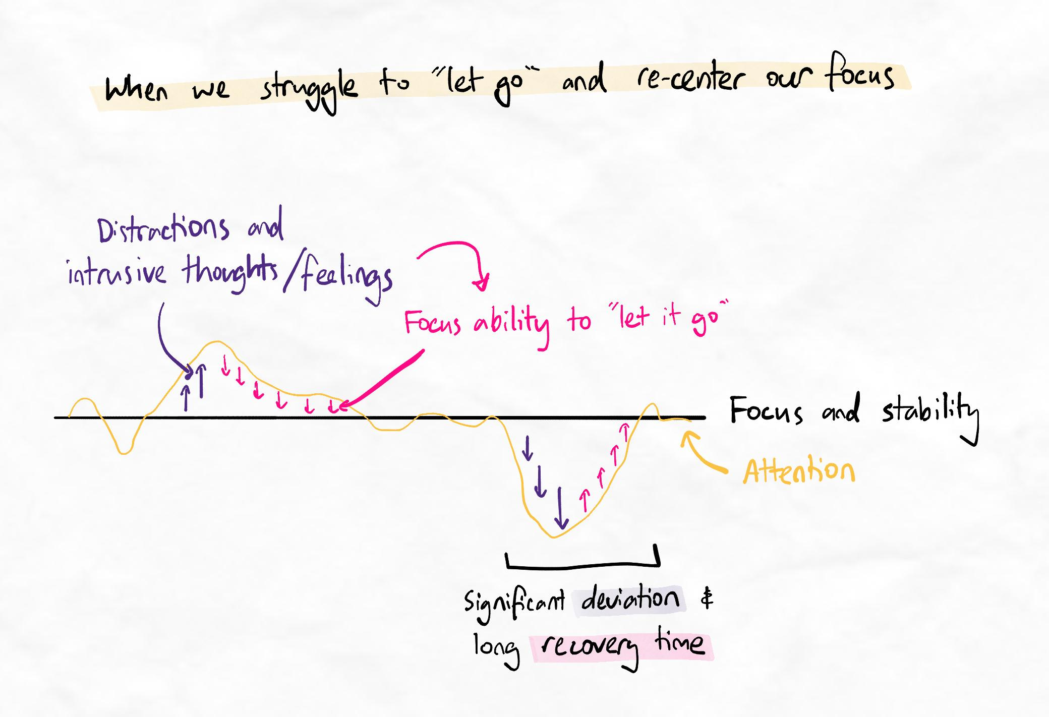When we struggle to let go of thoughts and feelings, it consumes our attention for a long time.
We can achieve this using focus training.
Focus training
Emotional self-regulation and remaining focused is less about forcing our brain to focus and much more about preventing our brains from being hijacked by thoughts and emotions. Focus training helps improve your brain's ability to let go of thoughts and feelings and return to a stable baseline.
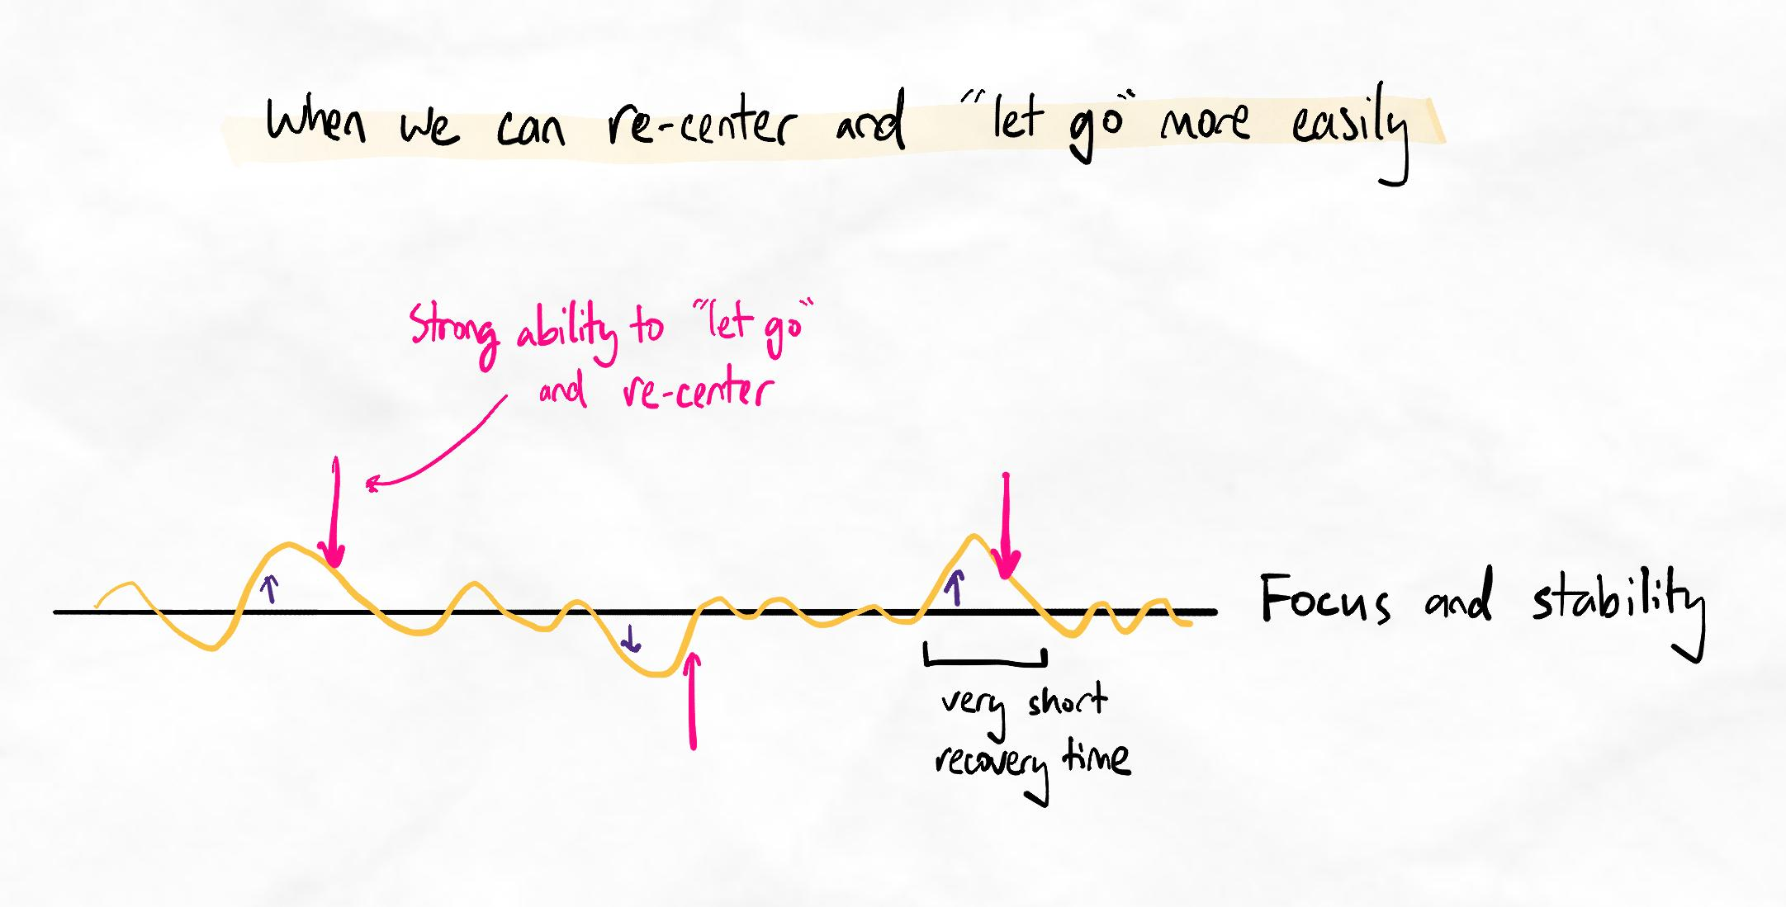Focus training helps us to "let go" and remain more stable.
In this way, focus can be considered a cognitive skill.
Training focus is conceptually simple:
- Put ourselves in a situation where our attention drifts (usually when there are no distractions - this is also why our mind wanders before we go to sleep).
- Practice letting go and bringing our attention back.
We can use the steps below to train ourselves.
Warning
If you have past trauma, focus training (which is a form of mindfulness meditation) can resurface traumatic memories. If you are aware of having past trauma, we recommend engaging in this activity with the guidance of a therapist or psychologist. Most trained therapists will be experienced in guiding clients on this technique.
Focus training instructions
- Sit somewhere comfortable away from distractions. Close your eyes.
- Take slow, deep breaths in and out.
- Focus on the sensation of each breath in and out. Be attentive to the air flow, how your body moves, and any other sensation associated with breathing.
- After a few seconds, you should start having other thoughts and your mind will wander. Each time your mind wanders, acknowledge the thought and let go of it without pursuing or fixating on it. Bring your attention gently back to your breathing.
- Repeat this process for 15 to 20 minutes (it's hard!)
You train your focus and self-regulation ability every time you let go and bring your attention back. It's normal for your mind to wander every three or four seconds. It can be frustrating at first, but remember that the point is to experience this and practice letting go and settling back into your breathing.
Over time, you will find this easier, and the time between wandering thoughts will grow longer. Even after years of practice, having no more than 10 seconds of "mental silence" is normal. However, this represents a tripling of focus ability!
Tip
Do not deliberately try to stop having distracting thoughts. Let those thoughts do what they will, like clouds floating in the sky or leaves floating down a stream. Observe them and let them pass without holding onto them, reaching out for them, or giving them your attention.
Therapeutic dose
The "dose" of focus training to make significant improvements is generally considered 20 minutes daily for 30 days. In our experience, effects are seen with just 10 minutes daily. Consistency is key.
We recommend anchoring this in your routine as a new habit to form.

Research on focus training/meditation
Read about Acceptance and Commitment Therapy (ACT) for youth and some of the metaphors it uses, including the yellow jeep. This is a form of cognitive behavioural therapy used by all clinical psychologists.
Read about mindfulness meditation and the related articles on this website to gain some basic knowledge about this highly effective practice.
There is so much research on mindfulness meditation and ACT that you may benefit from searching Google Scholar for those terms. There is a lot of very interesting research on many different types of people and problems.

Helpful apps
There are many apps to help with guided meditation. Different apps are suited for different people; however, you may wish to experiment with the following:
– Calm (usual top pick – start with 30-day beginner’s course)
– Insight Timer
– Buddhify
– Headspace
– Remente
– Tide
– Fabulous
– Smiling Mind
Some of these (such as Calm) also have free YouTube channels.

V. Neuroticism: management – chain analysis

Chain analysis
Chain analysis involves finding the causes of your responses and emotions. Clinical psychologists use this technique to help with neuroticism, and it is a versatile life-skill to gain mastery of. There are many ways to perform a chain analysis. One simple and effective version that psychologists may employ is outlined below.

1. Target behaviour
What is the specific behaviour that you want to change?
It could be a bad habit like procrastinating, over-eating, spending too much time on social media, binge-watching Netflix, or even emotional behaviours you use to cope, such as getting angry at someone and yelling at them

2. Prompting event
What was the event that sparked the chain leading to the target behaviour?
Be as specific as possible.

3. Vulnerability factors
What made you vulnerable to the prompting event?

This could be your state of mind, mood, preceding events, or even your habits that caused the event to affect you more than it might have for others or if it had happened on another day.

4. Links
What happened between the prompting event and the target behaviour? These are the links in the chain.
- What happened? How did you behave? How did you react?
- How did you feel at each point? How did your feelings evolve throughout the links?
- What thoughts did you have after the prompting event and before the target behaviour?
Be as specific as possible.

5. Consequences
What were the short-term and long-term consequences of your behaviour?

6. Solutions
What potential solutions can you use to change your behaviour in the future?
- Exposure: How can you limit your exposure to the prompting event or similar events? If this isn’t feasible, how can you limit your exposure to vulnerability factors?
- Skills: What skills can you develop or use to mitigate your vulnerability factors, reduce your exposure, modify and influence the events, behaviours, emotions and thoughts, or manage the consequences?
- Cognitive modifications*: How can you change your mindset or perspective about an event so that it has less of an impact on you emotionally and mentally? How will you remind yourself about this next time a similar trigger arises?
- Contingency management: We can’t always get things perfect. If all the previous steps fail, what can we do to reduce the short-term and long-term consequences? How can we help ourselves be more successful at reducing the previous steps in the future? Perhaps we need stronger reminders or a more specific or clearer structure and system.
*About cognitive modifications
Even if you don’t have the skills to manage and deal with problems directly, you can drastically reduce the influence and impact it has on you by changing how you perceive it.
For example, anxiety often becomes worse when you are aware of and actively focusing on not being anxious. This is an anxiety spiral and can lead to panic attacks. A cognitive modification such as acknowledging your anxiety, appreciating your brain’s reaction to try and protect you from danger, but reassuring it that there is no real danger to be afraid of, is a successful technique for managing anxiety spirals.
Cognitive modifications can be simple changes in mindset or perspective that you try to remind yourself of in the future. Or they can be more specific frameworks and techniques you learn from trustworthy sources.

Reminder: Custom tasks
If you struggle with neuroticism, a chain analysis will help you. We recommend creating a custom task to add chain analysis to your focus list. We have not created a recommended task for you because not everyone struggles with neuroticism and needs to do a chain analysis.
We leave the responsibility and decision to perform a chain analysis to your judgment.

5.Creating productive habits
PEER-Peer system
Now, we will introduce a system to ensure we curb our neuroticism. Remember, we want motivation to enhance our performance, but we don’t want to be dependent on motivation.
We will use the PEER-Peer system to execute actions. It has a low learning curve, is easy to set up, and you will see benefits immediately.
Alert
The PEER-Peer system is considered a core pillar technique of the program.

Table of contents
Sublesson
- Anatomy of a habit
- PEER-Peer system: Prep
- PEER-Peer system: Easy, exit, reward and peer
- PEER-Peer summary

- Anatomy of a habit
Cue and response
Optimising cue and response
- Identify the cues that trigger the response (i.e., the good or bad habit).
- Get rid of bad cues that cause you to respond undesirably.
- Adopt and integrate good cues that facilitate you to respond desirably.
For example, a bad cue might be seeing a social media icon when you open your browser or turn on your phone. Remove this cue by deleting the icon and browsing in incognito mode when you need to focus. Another bad cue might be seeing your phone, which you can remove by putting it at the bottom of your drawer or giving it to someone else.
A good cue for studying might be seeing your books open on the right page, which you can arrange the night before. A good cue for exercise might be seeing your running shoes, which you can arrange by hanging them off your doorknob.
Further learning
For a deeper and more focused set of lessons on how to create desirable behaviours and habits, check out the behaviour change modules in the supplementary learning section.
Conditioning a response
Another thing that affects our behaviour is conditioning. This occurs when an unrelated external stimulus can evoke the intended response.
For example, you can condition yourself to study (the response) by doing something that makes you happy immediately afterwards (the stimulus). Once your brain has conditioned itself, it will start to enjoy studying even when you don’t do the reward activity afterwards.

Read about classical (Pavlovian) conditioning
Here is a summary article on classical conditioning.
If you want to learn more, here is an extensive article on Wikipedia.

- PEER peer system – prep
P for Prep
We use the anatomy of a habit to create a robust system for conquering neuroticism: the PEER-Peer system. This involves planting good cues that help you study and removing bad cues that make you procrastinate. Make sure the bad cues are removed to the point that you would be too lazy to procrastinate!
If at first you don't succeed...
According to nudge theory and the broader field of behavioural science, changing your environmental cues is one of the most powerful influencers of behaviour. If your first cue optimisation is unsuccessful at creating the desired behaviour, optimise and optimise again!
It is rare for cue optimisation to be ineffective when repeatedly optimised.

Nudge theory: Environment is more important than willpower
Lots of research shows that the environment influences our behaviour more than willpower. This is called nudge theory – a branch of behavioural analysis science that explores how modifying our environment nudges us to engage in good or bad default behaviours.
Successful, productive people use nudge theory, while people who constantly burn out or rely on motivation only use willpower.
Read this article by James Clear, the author of Atomic Habits, on how we can optimise our environment for decision-making.

- PEER peer system – easy, exit, reward and peer
Easy
We make things ‘easy’ by establishing minimum viable goals (MVG), which we’ve discussed before.
Tip
Students often make their MVGs too difficult! If procrastination is a problem, even standing up or sitting at your desk can be considered a good MVG.
Exit
‘Exit’ means that at each MVG, you tell your brain you can quit anytime. This keeps your brain focused on the MVGs so that the final goal won’t scare you away.
Reward
Set a reward for whenever you attain a goal. Make sure your reward requires a minimum amount of work; try to make this time as long as possible. The closer you can get to your final goal before rewarding yourself, the better. It’s up to you to decide what is ‘good enough’ for a reward.
Tip
Do not let the reward tempt you prematurely. Consider physically locking away the reward, perhaps with the help of others. Often, people rely on willpower alone to stay away from their reward. We can see how this is prone to failure.
Peer
Peer is the last step. It creates another level of accountability using someone else (e.g., family, friends, or new friends from the iCanStudy community). We covered this when discussing the burnt ships strategy.
Once the behaviours have become habits, this step will no longer be necessary. The best thing about this system is that you will need to use it less and less as the behaviours all become fully automatic.

- PEER-Peer summary

Summary checklist
Expand the accordions below to see our checklist to ensure you are completing the PEER-Peer system effectively.

Prep
- Identify cues that trigger unwanted behaviours such as procrastination. Aim to identify at least three or more.
- Remove and lock away these cues however possible. Consider using site-blocking apps like SiteBlock. We want these “bad cues” to become INVISIBLE in our daily lives.
- Identify cues that trigger desirable behaviours. Aim to identify at least three or more.
- Plant these cues so that they are unavoidable in your daily life. We want these cues to almost intrude into our vision or path. Like a boulder rolling downhill to roll to the bottom inevitably, our environment should be crafted so that we inevitably roll towards our desired behaviour or action.

Easy
- Write your final desired goal (for example, studying for 3 hours).
- Write down all the steps required to get there. Make the first few steps as easy as possible to make it ridiculously easy to transition into your behaviour.
Conversely, we want to make our undesirable behaviour close to impossible. Try to write down the steps required to start your undesirable behaviour to see how easy it might be!
For example, procrastinating on social media might be as simple as taking out your phone and opening the app or tapping the button if you’re already on your phone. We can see how much more willpower it takes to do one type of behaviour (beneficial or productive) than another (harmful or time-wasting). This is partly because companies invest millions to make it as easy for us to get distracted as possible! They have crafted environments for us so we must take back control.

Exit
- Remind yourself that you can quit after every MVG. The only decision you need to make is whether you do the next MVG or quit.

Reward
- Identify two or three actions, behaviours, or activities you enjoy. Choose things that you can access and do readily. Consider how addictive your reward will be and if that affects your next scheduled task or event.
  - For example, if you have no other focus blocks planned after your reward break, it doesn't matter so much. Remember that a sleep and wind-down routine is also a scheduled task!
- Make this reward inaccessible without doing the desired behaviour.
  - For example, blocking Netflix outside of specific hours of the day or using an accountability partner (e.g. a parent) to show that you’ve completed something before getting them to unlock apps or websites.
Tips
- You can use incognito mode to stop getting personalised recommendations and subscriptions on YouTube that make it too easy for you to get side-tracked.
- You can also block specific words from appearing in the URL instead of blocking entire websites. For example, if you need YouTube for studying, use incognito to prevent easy access to your recommended content and subscriptions.
This forces you to search for videos manually. When you search for something on Youtube, the search term appears in the website URL; therefore, if you block those search words in your site blocker, your site-blocking app will allow you to search for “good” content while blocking the site every time the distracting search term pops up in the URL!
You can also enable these in the parental control options in most router settings.

Peer
- Find one or two accountability partners. Find a partner in the iCanStudy community if you need people on the same wavelength as you!
- Establish and agree to consequences.
- Ensure the consequences cause you to feel at least a moderate sense of dread and fear. If the consequence isn’t significant, your laziness or procrastination will win.
- Write down your agreed consequence to make it tangible and real. This symbolises that you are taking it seriously.
Tips
Find the balance. If the consequence is too extreme, you will likely lie to avoid the punishment. Find a consequence that is significant and undesirable yet not so extreme that you would avoid it at all costs. For example, giving someone $50 might be appropriate, while giving someone $500 is too extreme. Doing a dare in front of your class might be appropriate while doing a dare in front of your entire school during assembly might be too extreme.
Be responsible and do not act rashly.

Recommended tasks
Add tasks to your focus list so you can practice the skills.
Dimensions
Base Camp
Take control of your behaviours and habits using the PEER-Peer system
Using the checklist in our PEER-Peer system summary, create a plan to change your behaviours and develop new habits. Execute this plan for at least one week with at least three Kolb's cycles.
Complete this task after your week of experience using PEER-Peer.

6. Time management and prioritisation

In the sublessons below, we will further develop your time management and prioritisation skills, building on your current level of unconscious competence with the earlier skills and strategies you have practised.
Table of contents
Sublesson
- Priority myths
- Priority 0+1 system

- Priority myths
Myths
Myth 1: Working faster makes you more productive.
Your brain doesn’t work this way. You are not a factory – working faster will not necessarily produce more output. Instead, when you try to perform faster, the quality of your work decreases, and errors increase.
Of course, making errors due to poor understanding or retention is an unavoidable part of the learning process. However, we should still aim to reduce unnecessary or unproductive errors to avoid becoming inefficient.
Myth 2: Trying harder makes you more productive.
Often, people try so hard that they don’t have the mental space, time or perspective to see if their actions are correct. They become so consumed with trying hard that they don’t realise their efforts are not taking them towards their goals.
A great example is studying. Most students are so consumed with studying harder that they don’t even realise how bad their technique is. Even if they realise, they do not have time to learn to work smarter! Furthermore, activities that seem unproductive may improve productivity, like relaxing to maintain mental health.
Key principle
Hard work can prevent smart work. Working smarter requires time and mental freedom. If a standard of performance is only possible with high levels of effort, the only option is to take a short-term loss.

- Priority 0+1 system
Using Priority 0+1
Instructions
- Look at your goals and identify your top priority. You can use reverse goal setting principles to identify this.
- Block out time to accomplish your top priority.
- Fill the rest of your timetable according to your lower priorities.
- In the case of unforeseen events, shuffle lower-priority items to protect the highest priority tasks.
Eisenhower Matrix
To determine your priorities, use the Eisenhower Matrix, which categorises tasks by importance and urgency.
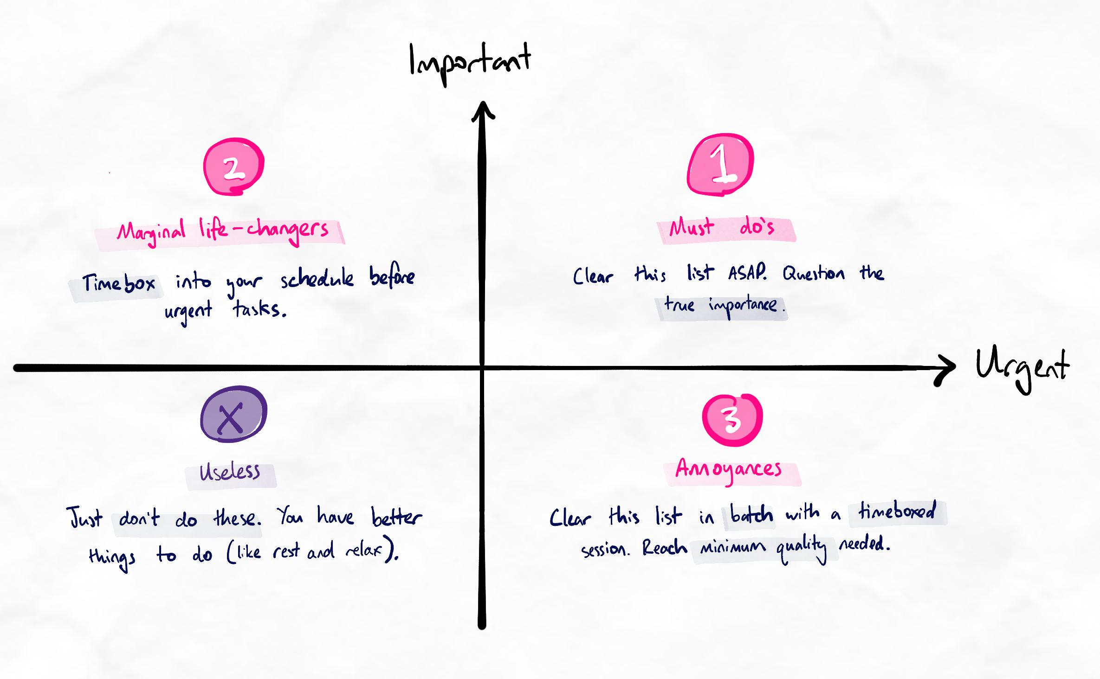Modified Eisenhower matrix showing priorities and instructions for each quadrant.
We recommend prioritising and scheduling your tasks the day before. On the day, keep a list of tasks that pop up and throw them into the Eisenhower matrix to prioritise and schedule for the next day.
Key principles for prioritisation
- Decide if tasks are important or not based on the consequence of failure; not an intuitive feeling of importance which is often based on urgency.
- Tasks with a low consequence of failure (that are acceptable and manageable) are not important, even if it "feels" important.
- Avoid scheduling urgent tasks first as this can lead to urgency trapping where time is constantly spent on urgent tasks and your future self is never more equipped to handle them or remove workload at the root cause.
Priority 0
Priority 0 refers to your values and goals. We recommend stepping back and reassessing these once every 6 months. Regularly reassessing your Priority 0 is important because it ensures that your Priority 1 tasks are aligned with your goals. It doesn’t take long and will save you a lot of time by keeping you on the right track.
Common questions
What are some examples of urgency trapping?
A common example of urgency trapping among students is filling all their time with urgent homework and never having time to work on study skills. If academic challenges increase faster than your skills, the gap between skills and challenges widens. This means students falling into this trap can eventually fail to reach academic goals as by the time it's felt as urgent, it is already too late.
This doesn’t mean you must schedule urgent tasks later in the day. It simply means you should schedule important and non-urgent tasks into your day first and fit in the urgent tasks around them.
For example, you could schedule 20 minutes every evening for meditation, which is important but non-urgent. You can then fill the afternoon with other tasks. This way, your urgent tasks will not preclude your important task (meditation).

How do you identify Priority 0?
Priority 0 comes to core values and long-term vision. Values are your fundamental beliefs that dictate how you behave and act. Long-term visions are open and abstract ideas of the type of person we want to be and the type of life we want to live.

What is the difference between a long-term vision and a long-term goal?
Your long-term vision is not a SMART goal. Setting goals that are too long-term can create tunnel vision. Over time, our personality and priorities are guaranteed to change. While some things remain with you for your entire life, it’s naïve to believe that we know enough about ourselves now to confidently think that it will not change for the next 10 years.
This is especially true before the age of 30 in modern society when you are transitioning into adulthood and experiencing many things for the first time. These new experiences are some of the most transformative moments that shape who you will be for the rest of your life. Instead of setting “goals” that are very specific, we can instead set visions.
Visions are a more open and abstract idea of the type of person we want to be and the type of life we want to live. This ensures that we have a broad checklist that we can use to calibrate our medium-term goals, making sure we are always heading in the right direction but not being so narrow that we close off other opportunities.
For example:
A long-term vision might be to have financial freedom, working at an intellectually stimulating job but with enough free time to explore multiple hobbies and interests. We want to be the type of person who is patient, calm, confident and capable of adapting and overcoming challenges enjoyably and easily.
This means that medium-term goals that do not take us closer to this long-term vision are unlikely to be good decisions. For example, getting tutoring to help us get better grades does not give us the skills to overcome challenges independently, nor does it increase our time management to give us the skills to have enough free time for hobbies and interests.

How often does Priority 0 change?
Always evaluate your long-term vision open-mindedly. It can be tempting and comfortable to believe that our long-term vision never changes, but this is unlikely.
We are a living, dynamic organism that constantly takes in information about the world and ourselves. We are always learning more about our thoughts, emotions, values, and experiences, shaping our personality and priorities. It is normal for your long-term vision to change, often in unexpected and sometimes radically different ways. Instead of going into this exercise assuming that your thoughts are unchanged, deliberately look for reasons, thoughts or emotions that indicate that what you want long-term has changed.
This helps us overcome the uncontrollable biases that can blind us from seeing our thoughts objectively. You can read more about cognitive biases here. You can evaluate your own cognitive biases here.
We recommend reviewing your Priority 0 every 6 months.

How often does Priority 1 change?
This priority 1 step should be repeated once every day or week, depending on how variable your schedule is. Busier people with more things going on in their lives will need to do this daily.

How can I be confident to delete tasks?
If the task is truly important, it will return to your list. Unless you have ample free time and a willingness to spend it on these tasks instead of relaxation, sleep, or more non-urgent, important tasks, it is not advisable to spend time on them.

7.OFF-rest timing
OFF-rest timing
Limitations of the Pomodoro technique
The Pomodoro technique is widely known and adopted but has disadvantages. After all, it did originate from a literal tomato cooking timer, not research!
The origin of the Pomodoro technique!
Unoptimised focus time
The first disadvantage is that your brain’s ability to focus will vary depending on the situation. If you’re focusing well (often called being in flow), you don’t want to cut off precious focus time prematurely, nor do you want to extend unfocused time if you can’t stay focused for the full 25 minutes.
Unoptimised rest time
The second disadvantage is that it doesn’t explain how to use the “rest” time. Having only five minutes to rest may be insufficient.
OFF-rest timing
Many people do not find the traditional Pomodoro technique sustainable and effective in the long term. As a result, most experienced and productive people do not use it at all. Instead, it is better to personalise the Pomodoro technique and optimise it for yourself. One variant that is commonly recommended instead is the Flowmodoro technique, which more closely resembles our guidelines and variation.
Ultimately, the important thing is that your method works for you. In our experience, OFF-rest timing is the most flexible and adaptable variant we have encountered, with compatibility in diverse settings.
OFF-rest timing is short for Optimised-For-Focus rest timing. It aims to keep your efficiency and focus high for as many cycles as possible throughout the day.
Using OFF-Rest timing
Use OFF-rest timing for extended work periods where you will have multiple cycles of work and rest.
The type of rest you take depends on the circumstances, but you still want to be as productive as possible during your breaks.
Analogy
Imagine moving a heavy boulder. The hardest part is getting it rolling in the first place. It takes very little energy and effort to keep it moving if you keep pushing it a little bit whenever it slows down. But if you wait until the boulder has completely stopped before pushing again, you must spend much more energy to get it back in motion.
Determining the type of break
- If you are relatively fresh, take a topical or miscellaneous break.
- If you are low on energy, take an active relaxation break (we suggest doing focus training or mindful meditation).
- Regardless, use a timer to measure how long you stay focused, and ensure that your rest time is one-third of your focused time.
Not all rest is equal
You should rest as soon as your brain is starting to become dull. This way, you can refocus and feel restored much more quickly. If we wait until we are noticeably tired before resting, refocusing and restoring our energy will take much longer, making us less productive overall.
You may also use the Wim-Hof breathing method during breaks to rapidly re-energise if you have less than 10 minutes. A tutorial on this helpful technique is here.
https://www.youtube.com/watch?v=tybOi4hjZFQ

Research on mindfulness meditation and work-rest timing
Beauchemin, J., Hutchins, T. L., & Patterson, F. ( 2008 ). Mindfulness meditation may lessen anxiety, promote social skills, and improve academic performance among adolescents with learning difficulties. Complementary Health Practice Review,13, 34 – 45.
Buchanan, Teresa K. “Mindfulness and Meditation in Education.” YC: Young Children, vol. 72, no. 3, July 2017, pp. 69–74. EBSCOhost, search.ebscohost.com/login.aspx?direct=true&db=ehh&AN=123903485&site=ehost-live&scope=site.
Burke, C. A. ( 2010 ). Mindfulness-based approaches with children and adolescents: A preliminary review of current research in an emergent field. Journal of Child and Family Studies,19, 133 – 144. 10.1007/s10826-009-9282-x
Carter, C. (n.d.). Pomodoro technique mastery: The unofficial beginner’s guide to instantly double your productivity for life.
Cahn, B. R., & Polich, J. ( 2006 ). Meditation states and traits: EEG, ERP, and neuroimaging studies. Psychological Bulletin,132, 180 – 211. 10.1037/0033-2909.132.2.180
Cirillo, F. (2013). The Pomodoro technique: Do more and have fun with time management (3rd ed.).
Johnson, Karen R., et al. “Mindfulness Training in the Workplace: Exploring Its Scope and Outcomes.” European Journal of Training & Development, vol. 44, no. 4/5, July 2020, pp. 341–354. EBSCOhost, doi:10.1108/EJTD-09-2019-0156.
Kember, P. ( 1985 ). The transcendental meditation technique and postgraduate academic performance. British Journal of Educational Psychology,55, 164 – 166. 10.1111/bjep.1985.55.issue-2
Lahikainen, Keith, and Champika K. Soysa. “Teaching Undergraduates about Mindfulness.” Journal of Human Services, vol. 34, no. 1, Fall 2014, pp. 5–23. EBSCOhost, search.ebscohost.com/login.aspx?direct=true&db=ehh&AN=100032705&site=ehost-live&scope=site.
Leland, Matt. “Mindfulness and Student Success.” MPAEA Journal of Adult Education, vol. 44, no. 1, Jan. 2015, pp. 19–24. EBSCOhost, search.ebscohost.com/login.aspx?direct=true&db=ehh&AN=109147952&site=ehost-live&scope=site.
Lin, Jian Wei, and Li Jung Mai. “Impact of Mindfulness Meditation Intervention on Academic Performance.” Innovations in Education & Teaching International, vol. 55, no. 3, June 2018, pp. 366–375. EBSCOhost, doi:10.1080/14703297.2016.1231617.
Nidich, S., Mjasiri, S., Nidich, R., Rainforth, M., Grant, J., Valosek, L., … Zigler, R. L. ( 2011 ). Academic achievement and transcendental meditation: A study with at-risk urban middle school students. Education,131, 556 – 564.
Wimmer, Lena, and Dusana Dorjee. “Toward Determinants and Effects of Long-Term Mindfulness Training in Pre-Adolescence: A Cross-Sectional Study Using Event-Related Potentials.” Journal of Cognitive Education & Psychology, June 2020, pp. 65–83. EBSCOhost, doi:10.1891/JCEP-D-19-00029.
VIDIC, ZELJKA, and NICHOLAS CHERUP. “Mindfulness in Classroom: Effect of a Mindfulness-Based Relaxation Class on College Students’ Stress, Resilience, Self-Efficacy and Perfectionism.” College Student Journal, vol. 53, no. 1, Spring 2019, pp. 130–142. EBSCOhost, search.ebscohost.com/login.aspx?direct=true&db=ehh&AN=136193468&site=ehost-live&scope=site.
Weinstein, C. E., & Underwood, V. L. ( 1985 ). Learning strategies: The how of learning. Thinking and Learning Skills,1, 241 – 258.
Zahariades, D. (2015). The Pomodoro technique: A 10-step action plan for increasing your productivity (1st electronic ed.).
Zeidan, F., Johnson, S. K., Diamond, B. J., David, Z., & Goolkasian, P. ( 2010 ). Mindfulness meditation improves cognition: Evidence of brief mental training. Consciousness and Cognition,19, 597 – 605. 10.1016/j.concog.2010.03.014
Web article on 5217 as an alternative to Pomodoro: https://www.themuse.com/advice/the-rule-of-52-and-17-its-random-but-it-ups-your-productivity

Recommended tasks
Add tasks to your focus list so you can practice the skills.
Dimensions
Base Camp
Utilise OFF-rest timing during your intensive focus sessions
Apply the OFF-rest timing method to keep focus optimum throughout at least one long work/study session.
Complete this task after you have experimented with this method for at least three work cycles.

8. Final checkpoint – base camp

Checkpoint tasks
Complete the recommended tasks below before moving on to the competence assessment and checklist below.

Recommended tasks
Add tasks to your focus list so you can practice the skills.
Dimensions
Base Camp
Complete a Base camp challenge fortnight
Complete a challenge fortnight (two weeks) applying all the methods and techniques you have learned. The methods should include:
  - Encoding and SIR methods
  - Time and task management
  - Focus and attention management
  - Regular critical reflection
The challenge can be considered successfully complete if you are able to achieve all methods to good effect and with relatively high consistency. Ensure at least 5 Kolb's cycles within this fortnight.
Complete this task once you have completed the challenge fortnight and your final Kolb's cycle.
Dimensions
Ascent II
Complete a skill audit
Using the checkpoints and meta-checklists so far, complete a skills audit on your current skill level and learning system. Implement any findings as experiments into your next Kolb's cycle.
Complete this task once you have completed your skill audit.

Checkpoint items
- You should have an extremely high level of competency (at or approaching unconscious competence) for all prior techniques.
- You should have significant efficiency gains and a high level of knowledge mastery and retrieval.
Competence assessment
Technique(s) | Level of Competency
Hipshot variation | You have comfortably replaced Aim and Shoot with the hipshot variation.  You can use the hipshot variation with moderately low effort.
Focus training | You can do focus training consistently and can easily tolerate the feelings of “boredom” or “restlessness”.  You have started to feel an increase in focus in general, not just immediately after focus training.  You use focus training intermittently throughout the day.
PEER-peer system | You are very comfortable and confident in creating new habits.  You can easily manage (or have wholly removed) procrastination.  You also know which parts of the PEER-peer system are more effective for different habits or moods.
Priority 0+1 system + Scheduling | You can prioritise and schedule accurately and flexibly daily.  (This process should now feel like second nature.)
OFF-Rest timing | You can dynamically adjust your rest timing and rest-activity to optimise productivity.  (This should now be second nature.)

Progress Check

Procrastination
On a scale of 1 to 10, how well do you manage procrastination?
1 is very poorly (you significantly struggle with procrastination). 10 is very well (you do not have problems with procrastination at all).
Learning
On a scale of 1 to 10, how efficient would you rate your learning ability?
1 is not at all efficient. 10 is very efficient (able to cover large volumes with high depth and retention in a short time).
Confidence
On a scale of 1 to 10, how confident are you to overcome learning challenges and reach your learning goals?
1 is extremely unconfident. 10 is extremely confident.
Learning
If you have had an assessment (e.g. an exam) in the last four weeks, what results did you achieve?
96 to 100%91 to 95%86 to 90%81 to 85%76 to 80%71 to 75%65 to 70%60 to 64%Below 60%No recent assessment
Compared to your baseline performance, how would you rate your most recent learning performance?
Significantly worse
Worse
Similar
Improved
Significantly improved
Baseline is considered your normal level before joining our program.
Your experience
Have you noticed any other benefits or improvements that were not mentioned in the questions above?
For example, improvements in mood, sleep, career development, free time, well-being, or employability.
This is optional.

